1. Compare fork(), vfork(). Write a C program to create a child process and print the PID and PPID in the child process. The parent must wait for child and print exit status of the child using appropriate macros.
Ans: Process creation in UNIX is fundamentally done using the fork() function, which creates a copy of the calling process. The vfork() function is an obsolescent variation historically provided for efficiency, especially when the child immediately intends to execute a new program. ()

Comparison of fork() and vfork()
The two functions have the same calling sequence and return values, but their semantics differ significantly:
Feature | fork() | vfork() | Source
1. Address Space | Creates a copy of the parent's data space. Parent and child do not share memory. | Child process shares the parent's address space. | , 234
2. Memory Efficiency | Generally slower due to address space copying. | Faster as it completely avoids address space copying.
3. Execution Order | Kernel determines execution order; unpredictable. | Guarantees that the child runs first. | , 235
4. Parent State | Parent runs concurrently with the child. | Parent is suspended until the child calls exec or exit().
5. Data Modification | Modifying variables in the child is safe. | Modifying data in the child leads to undefined results.
6. Intended Use | General process creation. | Intended to be followed immediately by an exec call.
7. Standard Status | A standard, portable POSIX function. | An obsolescent interface; non-portable.

C Program (PID, PPID, Wait, Exit Status)
C
#include <stdio.h>
#include <stdlib.h>
#include <unistd.h>
#include <sys/wait.h>

int main(void) {
pid_t pid;
int status;

if ((pid = fork()) == 0) {
//Child Process
printf("Child PID: %d, Parent PID: %d", getpid(), getppid());
exit(7); // Terminate with status 7
} else if (pid > 0) {
//Parent Process
wait(&status);
printf("Parent waited for child PID: %d", pid);
if (WIFEXITED(status)) {
printf("Child exit status: %d", WEXITSTATUS(status));
}
}
return 0;
}
Conclusion: The fork() call is the fundamental method, ensuring memory separation. The parent process uses wait() to synchronize with the child's termination and retrieve its exit status, which is analyzed using status-testing macros like WIFEXITED and WEXITSTATUS.

3. Explain the UNIX Kernel support for process. Show the related data structures.
Ans:
Introduction:
The UNIX kernel provides comprehensive support for processes, which are the fundamental units of execution, by managing their life cycle and maintaining critical state information about each one.

UNIX Kernel Support for Processes
- Process Identifiers: The kernel assigns and maintains a unique Process ID (PID) and tracks its creator using the Parent Process ID (PPID), retrievable via getpid() and getppid(). ()
- Special Process Management: It ensures that Process ID 1 is the init process, which is invoked during system bootstrap and adopts any orphaned processes. ()
- Process Creation (fork): The kernel implements the fork() system call, which handles the complex task of duplicating the parent's resources (data space, stack, heap), while sharing the text segment for efficiency. ()
- Program Replacement (exec): The kernel supports the exec family of functions, allowing a process to replace its entire program image with a new one without changing its PID. ()
- Process Synchronization (wait): It provides wait and waitpid functions, enabling a parent process to wait for a child's termination, thereby cleaning up zombie processes and retrieving the child's exit status. ()
- User/Group Management: The kernel maintains the process's associated effective and real user IDs (getuid, geteuid), group IDs, and supplementary group IDs. ()
- Data Structures: The kernel manages all processes using internal data structures, most importantly the Process Table, where each entry stores the state and characteristics of a single process.

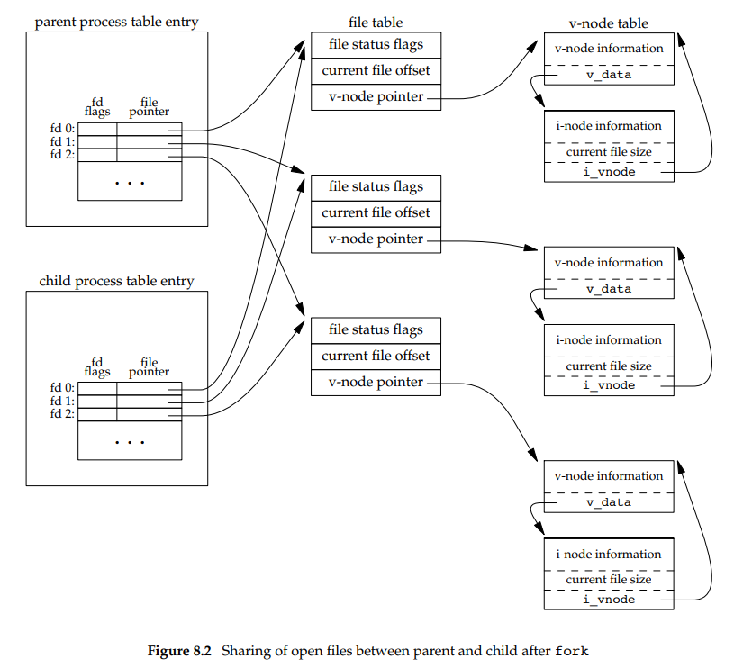

Conclusion: The UNIX kernel is central to process management, providing essential functions (fork, exec, wait) and maintaining state information through internal data structures.

8. Describe what are pipes? What are its limitations?
Ans:
A pipe is a fundamental mechanism for Interprocess Communication (IPC) in UNIX. It is implemented as a temporary, kernel-managed circular buffer that enables reliable, sequential data transfer between processes.

Description of Pipes
- Half-Duplex Flow: A single pipe provides a unidirectional (half-duplex) data channel. Data is written by one process at the write end and read sequentially by another process at the read end.
- Creation: An unnamed pipe is created using the pipe() system call. This function returns an array of two file descriptors: fd[0] for the reading operation and fd[1] for the writing operation.
- Process Inheritance: The pipe is established when the fork() system call is executed after the pipe is created. The child process inherits copies of both descriptors, setting up the required communication link between the related processes.
- Synchronization Utility: Beyond data transfer, a pipe can be used as a coarse synchronization primitive. By having one process block on a read() operation until the other process performs a corresponding write(), a basic signal mechanism can be implemented.

Limitations of Pipes
- Unidirectional Restriction: The most significant constraint is that a single pipe is strictly half-duplex. Achieving true full-duplex (two-way) communication requires the application to explicitly create and manage two separate pipes.
- Related Processes Constraint: An unnamed pipe can only be used for communication between related processes (parent, child, or siblings). This is because the communication relies on the child inheriting the necessary file descriptors from the parent.
- Byte Stream Nature: Pipes function as a raw byte stream. They do not intrinsically respect message boundaries or structures. Consequently, the communicating processes must agree on an external protocol to delineate message units (e.g., fixed lengths or terminators).
- Socket Alternative: For scenarios demanding complex bidirectional communication between unrelated processes, more advanced IPC mechanisms like UNIX domain sockets are necessary.

Conclusion:
Pipes offer a simple, efficient, and low-overhead means of unidirectional data transfer between related processes. However, their fundamental constraints—the single-direction flow and the requirement for process lineage—limit their utility in complex IPC architectures.

9. Explain the APIs used to create and control the semaphores?
Ans:
Introduction:
Semaphores in UNIX are controlled through two primary, distinct sets of APIs: the portable POSIX Semaphores and the older XSI Semaphores (System V IPC).

APIs Used to Create and Control Semaphores
- POSIX Semaphores (Standard Interface):
  - Header: <semaphore.h>
  - Creation/Control: Functions like sem_open() are used to create or open a named semaphore. sem_unlink() is used for removal.
  - Operations: sem_wait() is used to decrement the semaphore count (lock/wait), and sem_post() is used to increment the count (unlock/signal).
- XSI Semaphores (System V Interface):
  - Header: <sys/sem.h>
  - Creation: semget() is used to create a new semaphore set or to get the ID of an existing set.
  - Control: semctl() is a general control function used for tasks like initialization, removal, and setting permissions for the semaphore set.
  - Operations: semop() is used to atomically perform operations (wait and post) on one or more semaphores within the set.
Note: The detailed explanation of the API function specifics is not available in the provided pages from the textbook.
Conclusion: Developers choose between the simpler POSIX API for portability and the more complex XSI API, which offers greater flexibility through control over semaphore sets.

9. Explain the APIs used to create and control the semaphores?
Ans:
Introduction:
Semaphores are synchronization primitives controlled through two main sets of APIs in UNIX: the more modern, portable POSIX Semaphores and the older, complex XSI (System V) Semaphores. These APIs define functions for initializing, manipulating (wait/post operations), and cleaning up semaphores.
POSIX Semaphore APIs
This interface is defined under the POSIX standard and is generally simpler and more portable, utilizing the <semaphore.h> header.
- sem_open():
  - Purpose: Used to create a new named semaphore or open an existing one. It returns a pointer of type sem_t.
- sem_wait() / sem_trywait():
  - Purpose: Performs the Wait (P) operation. It decrements the semaphore's count. If the count is zero, the calling thread/process is blocked until the semaphore is signaled.
- sem_post():
  - Purpose: Performs the Signal (V) operation. It increments the semaphore's count. If any threads/processes are waiting, one is awakened.
- sem_close() / sem_unlink():
  - Purpose: Used for cleanup. sem_close() releases the semaphore from the process address space, while sem_unlink() removes the named semaphore from the system.
XSI (System V) Semaphore APIs
This older, more complex interface manages semaphores in sets and is defined using the <sys/sem.h> header.
- semget():
  - Purpose: Used to create a new semaphore set or get the ID of an existing set, identified by a key. It returns the set identifier (ID).
- semctl():
  - Purpose: A general control function used to perform various actions on the semaphore set. This includes initializing the semaphore values or removing the semaphore set from the kernel.
- semop():
  - Purpose: Used to perform operations (Wait/Post) on one or more semaphores in the set. It takes an array of sembuf structures, allowing multiple operations to be executed atomically.
Conclusion:
The APIs for semaphores are divided between the portable POSIX standard and the complex XSI option. POSIX uses distinct functions for creation and operation (sem_open, sem_wait), while XSI uses a consolidated set of functions (semget, semctl, semop) to manage semaphore sets.

